Lab 11: Swing Up Control

EEE4514

April 11, 2017

**Gabriel Stroe**

# Filtering

## Overview

The purpose of this lab is to configure the rotary pendulum system so it will begin to balance itself after the user moves it to 20 degrees just as it did in lab 10, as well as swing itself up to a 20 degree positions.

## Theory and Methods

To accomplish this, this lab takes lab 10’s balance control and implements it as a subsystem for this lab. It changes the angle of when the balance control starts from 10 to 20 degrees.

Since the block diagram for the swing up control is already made for us due to the time given, the main components to adjust in this lab is mu (the acceleration per unit of energy), Er (the energy reference), and u max (the maximum acceleration allowed).

By adjusting our mu to provide enough force to propel the pendulum up we can get the pendulum to balance. It is also worth noting that there needs to be a high enough Er to get this to stand as well.

## Results

The lab worked very smoothly from the beginning. After following the lab manual we were able to get the servo to swing the pendulum and have it balance itself. Below is an output of the servo motor doing exactly that at a mu = 60 and an Er of 25:

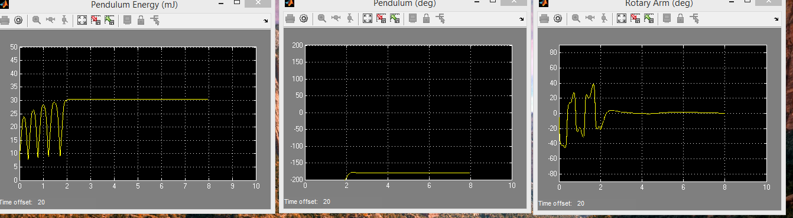

## 2.1 Questions

1. Yes, the energy starts at zero when its pointing down and it reaches a peak energy when it is pointing up.

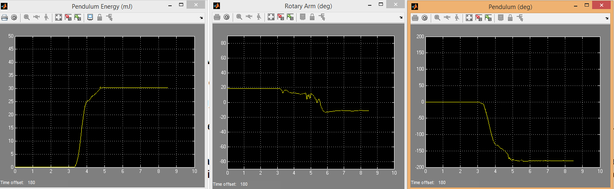

1. Er = 10:  
     
   Er = 22:  
     
   As it stabilizes at Er=22:

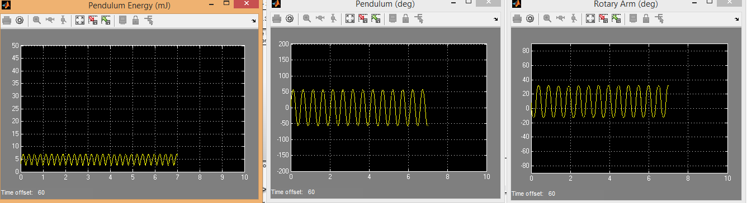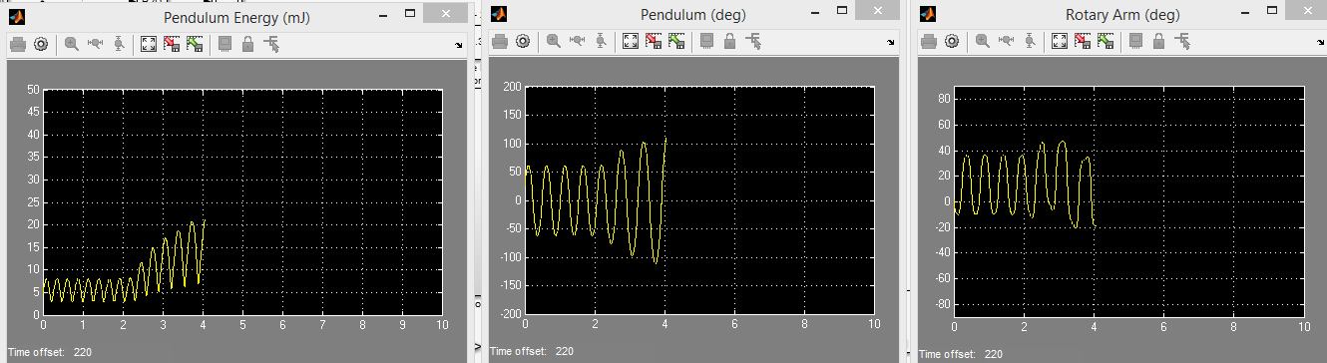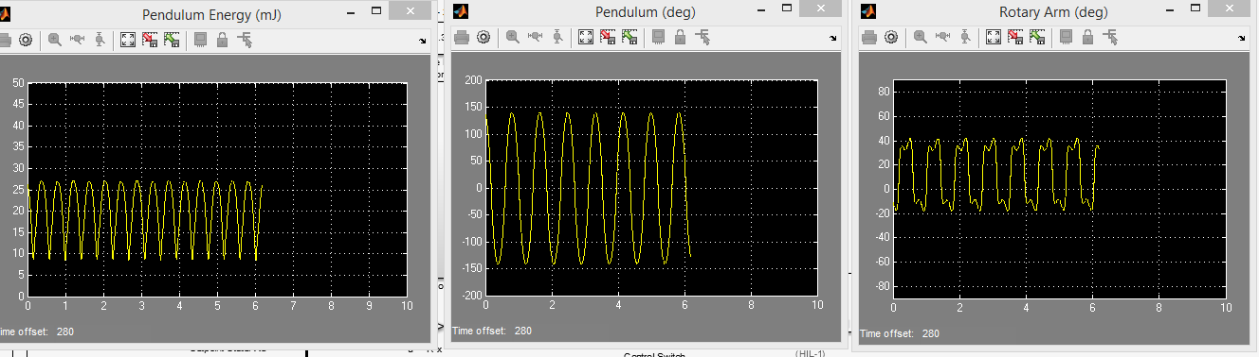

1. At mu = 20 from 40:  
     
   At mu = 60 from 20:  
     
   As we increase mu the system applies more force to its swing allowing the amplitude to increase.

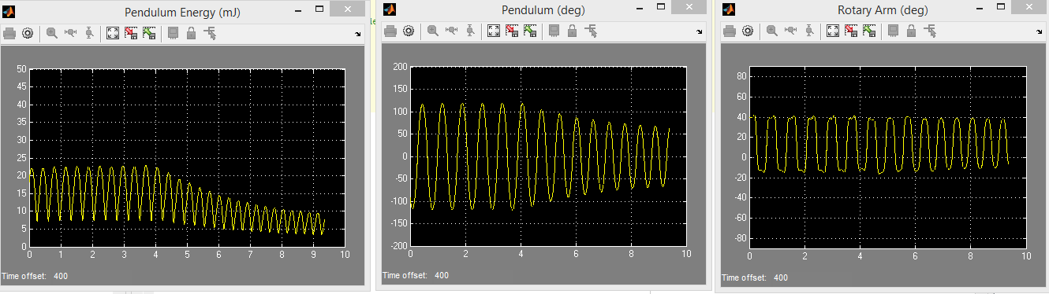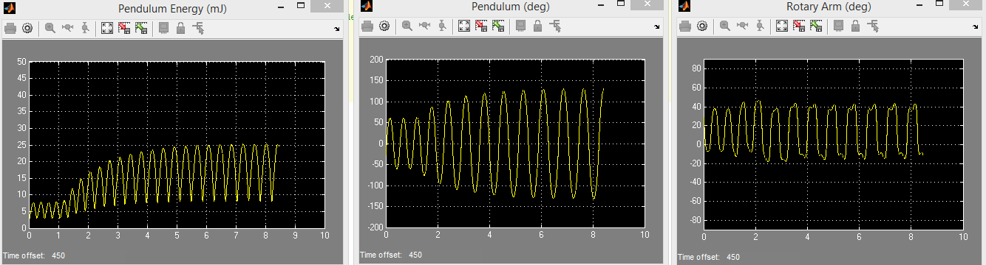

## 2.2 Questions

1. The energy reference needs to be set to something higher than 20. We will use 25 for our model.
2. 

## Conclusion

This was a conclusion to what we have be learning in all of the previous labs. Every system that was setup and calculated, every controller we created, and every gain applied was done so we can understand exactly how this system would work. In the end I found this to be a very good conclusion in itself for these labs. All made better that we were able to set it up and get it working quickly.